**DESIGN AND IMPLEMENTATION OF BLOOD BANK INFORMATION MANAGEMENT SYSTEM**

# **COVER PAGE**

**BY**

**ADAKOLE, JEFFREY ODEH**

**2015/1/56189CI**

**PROJECT SUBMITTED TO THE DEPARTMENT OF INFORMATION AND MEDIA TECHNOLOGY, SCHOOL OF INFORMATION AND COMMUNICATION TECHNOLOGY, FEDERAL UNIVERSITY OF TECHNOLOGY, MINNA, NIGERIA IN PARTIAL FULFILLMENT OF THE REQUIREMENT FOR THE AWARD OF THE DEGREE OF BACHELOR OF TECHNOLOGY IN INFORMATION AND MEDIA TECHNOLOGY (INFORMATION TECHNOLOGY)**

**JULY, 2021**

# **DECLARATION**

I ADAKOLE, Jeffrey Odeh with Matriculation Number- 2015/1/56/189CI hereby declare that this project titled: Design and Implementation of a Blood Bank Information Management System is a collection of my original project work and it has not been presented for any other qualification anywhere. Information from other sources (published or unpublished) has been duly acknowledged.

|  |  |  |
| --- | --- | --- |
| ADAKOLE, Jeffrey Odeh |  |  |

2015/1/56189CI Signature and Date

Federal University of Technology,

Minna, Nigeria.

# **CERTIFICATION**

I certify that this research study: Design and Implementation of Blood Bank Information Management System was carried out by ADAKOLE Jeffrey Odeh (2015/1/56189CI) in the Department of Information and Media Technology, School of Information and Communication Technology, Federal University of Technology Minna, under my supervision.

|  |  |  |
| --- | --- | --- |
| Mr. Ikwuazom T. Callistus |  |  |

Project Supervisor Signature and Date

|  |  |  |
| --- | --- | --- |
| Prof. Jude Terna Kur |  |  |

Head of Department Signature and Date

|  |  |  |
| --- | --- | --- |
| Dr. Iorshashe Agaji |  |  |

External Examiner Signature and Date

# **DEDICATION**

This project report is dedicated to God Almighty who gave me good health, strength, courage and the ability to complete this report successfully. I also dedicated this project to my beloved parents and my siblings for their moral and financial support.

# **ACKNOWLEDGEMENTS**

My profound gratitude goes to my Heavenly Father, God Almighty for giving me the strength and grace to complete this program of study.

I will like to sincerely thank my supervisor, Mr. Callistus T. for his understanding, tolerance and advice through the duration of this research work.

I will also like to appreciate my parents, Mr. and Mrs. Okpani Adakole for their moral and financial support all through the duration of this work.

To the entire staff of Information and Media Technology Department, Federal University of Technology, Minna, I am grateful for all your help, assistance, encouragement and advice to me. God bless you all and may all of you continue to grow from strength to strength.

To all my siblings, Mr. Agbo Adakole, Mr. George Adakole, Miss. Joy Adakole, Mrs. Mercy Ekpoto, Mrs. Ann Adode, Mr. Emmanuel Adakole, Miss Mary Adakole, Mr. Desire Adakole, Mr. Charles Adakole and Miss. Praise Adakole thank you for your encouragement all through this period. Also, I will like to thank Mr. Ekpoto and Mr. Adode for their support.

Lastly, to my friends, Enemona and a host of others too numerous to mention and course mates, to you all I say a very big thank you, for we made it despite all the struggles. And also, to all who contributed to my success this far one way or the other.

# **ABSTRACT**

The manual method of processes relating to blood bank management in Nigeria hospitals is no longer efficient and effective due to the cumbersome method of paper filing that result in loss of data, inaccurate record keeping and much complexities. Hence, the quest for a convenient, proper, and easier handling of this processes necessitated this project "Design and Implementation of Blood bank information management system". This web-based project makes it easy to give information regarding donors’ blood type, date of donation and available blood group, also the importance of blood donation. After implementation, the blood searching process is expected to be faster, easier, and reliable as it provides a means for the Administrator to be able to view the donor side and the available blood requested by the users. The system also provides user-friendly interfaces that allows people to easily interact with. It is the best substitute for the current paper filing method which would help eliminate information inconsistency, loss of vital data files.

# **TABLE OF CONTENT**

**COVER PAGE** i

**DECLARATION** ii

**CERTIFICATION** iii

**DEDICATION** iv

**ACKNOWLEDGEMENTS** v

**ABSTRACT** vi

**TABLE OF CONTENT** vii

**LIST OF TABLES** viii

**LIST OF FIGURES** x

**CHAPTER ONE** 1

INTRODUCTION 1

1.1 Background of the Study 1

1.2 Statement of problem 3

1.3 Significance of Study 4

1.4 Aim and Objectives 4

1.5 Scope and Limitation of the Study 5

1.6 Organization of the Study 5

1.7 Definition of Operational Terms 6

**CHAPTER TWO** 8

LITERATURE REVIEW 8

2.1 General Information 8

2.1.1 Blood Donation Process 12

2.2 Related works 14

2.3 Summary of Review 16

**CHAPTER THREE** 19

SYSTEM ANALYSIS AND DESIGN 19

3.1 System Analysis 19

3.1.1 Analysis of the Existing System 19

3.1.2 Limitations of the Existing System 20

3.1.3 Justification for the New System 20

3.1.4 Description of the New System 21

3.2 Design of the Proposed System 22

3.2.1 Data Model 23

3.2.2 Functional Requirements 24

3.2.3 System Architecture 31

3.2.4 Software Architecture 33

3.2.5 Workflow of Use Cases 34

**CHAPTER FOUR** 36

IMPLEMENTATION AND DISCUSSION 36

4.1 System Requirement for Development 36

4.1.1 Technology used 36

4.1.2 Hardware Requirements 38

4.2 System Menus Implementation 39

4.2.1 The Home Page 39

4.2.2 The About Page 40

4.2.3 The Frequently Asked Question page 41

4.2.4 The Contact page 42

4.2.5 The New Donor Registration Page 43

4.2.6 Request for Blood Form 44

4.2.7 The Admin Side of the Site 45

4.2.7.1 Home 46

4.2.7.2 Blood Donors 47

4.2.7.3 Blood Donations 47

4.2.7.4 The Admin Users Panel 48

4.2.7.5 The Admin Blood Request Deliveries Panel 49

4.3 Database Implementation 50

4.4 System Testing 52

**CHAPTER FIVE** 53

CONCLUSION AND RECOMMENDATIONS 53

5.1 Conclusion 53

5.2 Recommendation 54

**REFERENCES** 55

**APPENDIXES** 59

# **LIST OF TABLES**

Table2.1 : Summary of Literature Review 17

Table 3.1: User Table 29

Table 3.2: Donor Table 29

Table 3.3: Request Table 29

Table 3.4: Blood Inventory Table 30

Table 3.5: Handover Request Table 31

Table 3.6: Message Table 31

Table 4.1: System Testing Results 52

# **LIST OF FIGURES**

Figure 3.2: Proposed System State chart diagram 22

Figure 3.4: Entity Relationship Diagram 24

Figure 3.5: Use Case Diagram of the Proposed System 25

Figure 3.6: Deployment Diagram. 32

Figure 3.7: Class Diagram. 33

Figure 3.7: Activity Diagram. 35

Fig. 4.1: The Home Page of the system 39

Fig. 4.2: The About interface of the system 40

Figure 4.3: The Frequently Asked Question page 41

Figure 4.4: The Contact page 42

Figure 4.5: The New Donor Registration Page 43

Figure 4.6: The Request for Blood Form 44

Figure 4.7: The Admin Login Panel 45

Figure 4.8: The Admin Home Panel 46

Figure 4.9: The Admin Blood Donors Panel 47

Figure 4.10: The Admin Blood Donation Panel 47

Figure 4.11: The Admin User Panel 48

Figure 4.12: The Admin Blood Delivery Panel 49

Figure 4.13: Blood Inventory Table 50

Figure 4.14: Donors Table 50

Figure 4.15: Handover Request Table 51

Figure 4.16: Messages Table 51

Figure 4.17: Request Table 51

Figure 4.18: Users Table 52

# **CHAPTER ONE**

# **INTRODUCTION**

**Introduction**

Blood is vital and it is one of the most critical elements of human life. Blood is referred to as ‘river’ of life because it is a fluid in humans and other animals that supplies the necessary essential substances such as nutrients and oxygen to the cells and also transports waste products away from the cells. In the medical field, blood donation and transfusion service involve collecting, processing, storing and providing human blood intended for transfusion, performing pre-transfusion testing, crossmatching, and finally infusing into a patient. Generally speaking, the blood bank system consists of the independent blood centers, which collect, store and distribute human blood, and hospital blood banks charging of transfusion related services.

## **1.1 Background of the Study**

Given the life-threatening nature of blood and blood components, it entails the rigorous controlling, monitoring and the complete documentation of the whole procedure from blood collection to blood infusion. Blood comprises of various constituent which has different functions. The various components and their functions are; (a) Plasma – the medium in which blood cells are transported around the body, (b)Platelets – which facilitates to blood clotting and also the need for blood transfusion (c) White blood cells (WBCs) – the part of the immune system, (d) Red blood cells (RBCs) – it carries oxygen, and (e) Hemoglobin – which is an essential chemical in the body and carries oxygen from the lungs to other part of the body mm.

According to (Selvamani & Kumar Rai, 2015), statistically blood is needed by someone in a every two seconds, hence the importance of blood transfusion. The various component of blood is administered to patients based on patient’s condition. Blood is used for trauma victims and burns – heart surgery, organ transplants, women with complications during childbirth, newborns and premature babies, and patients receiving treatment for leukemia, cancer or other diseases, such as sickle cell disease and lymphoma. Despite significant advancement of technology in medicine, the human race has not been able to find suitable substitute for blood. For this reason, blood is a vital and expensive commodity in health care systems (Najafi et al., 2017). All the activities needed to allow the transfusion of blood from the donors to patients are performed by blood management systems, composed of a set of dedicated facilities (usually blood centers), that are linked to hospitals and other types of health centers. (Bruno et al., 2019).

Blood is collected in an anticoagulant tube, tested for proofs of infections, processed, stored and then transfused to patients; collected blood may be transfused in an unmodified state (whole blood transfusion) or, it can be separated into components (such as red cell concentrates, platelet concentrates, plasma) or transformed into plasma-derived medicinal products, useful for a large range of therapeutic purposes. In high income countries, transfusions are commonly used for supportive care in cardiovascular surgery, transplant surgery, massive trauma, and therapy for solid and hematological malignancies. All these activities are being done in these facilities, the blood centers (Blood bank) (Bruno et al, 2019).

Blood bank refers to a division of a hospital where the storage of blood products occurs and also where proper testing is performed to reduce the risk of transfusion related problems or issues. The donation and transfusion of blood service is an essential part of modern medicine and healthcare which involves the collection, processing, storing and provision of human blood intended for transfusion, performance of pre-transfusion testing, cross-matching, and infusing into a patient. Blood bank system generally consists of independent blood centers which collect, store distribute the human blood as needed, and apply charges for other transfusion-related services (Li & Chao, 2008)

Blood management has been considered a challenging process given the life-threatening nature of blood and its components as it requires the intense controlling, monitoring and the complete documentation of the whole procedure from blood collection to blood infusion and at same time the decentralized affairs involved in this procedure further complicate the effective administration of blood donation and transfusion services (Li & Chao, 2008)

Fortunately, the advent and development of information and computer technology which has been widely deployed in medicine reveals the great potential to improve efficiency as well as quality in terms of blood donation and transfusion services, combined with various automation apparatus (Bing Nan Li et al, 2008). Obviously, this can secure and ease the complexities of donor screening, blood collection, laboratory testing and cross-matching, even down to addressing the issue challenging blood banks, namely, the complete documentation for possible backward inspection. Information processing plays a vital role in blood banking practice. A digitalized blood bank information system generally refers to acquiring, validating, storing, and circulating various data and information electronically in blood donations and transfusion. Proper management of information related to blood donors, blood components, and patients receiving transfusions is crucial to ensuring the safety and traceability of blood products. The essence of a blood management system is to ensure and assure that such components are readily available in an efficient way to patients whenever and wherever they are needed.

Blood bank information management system is a web-based application system that is designed for storing, retrieving and analyzing information concerning the administrative and inventory management within a blood bank. It is also aimed at digitalizing all the information and management process pertaining to blood donors.

## **1.2 Statement of problem**

The existing system for managing the blood bank at General Hospital Minna, Niger State is a manual system. Due to manual operation and cumbersome methods (paper file) in use, the hospital is exposed to data and information lost as a result of lack of recovery measure in terms of disaster to handle data recovery and also the large volume of data, complexity sets in and as a result inaccurate record keeping of blood stocks would be inevitable and both patients and donor’s records would also be inevitable. Also, because information is localized.

From the above analysis, there is need for the digitization of blood bank information management system at the General Hospital, Minna, Niger State so as to remove procedures that cause data redundancy through the existing paper filling system and make navigational sequence proper to enhance efficiency and effectiveness. This project therefore seeks to develop a Blood Bank Information Management System (BBIMS) for the General Hospital, Minna, Niger State.

## **1.3 Significance of Study**

The significance of this study is basically to aid automate the complete operations of the hospital’s blood bank. The need for maintaining thousands of records so as to avoid data redundancy and also miss match during operations is very paramount. Furthermore, to ease the search for blood in cases of emergences. The utmost importance of this study as follows;

1. Minimizing data lose by the introduction of electronic data storage.
2. To serve as a site for interaction of best practices so as to reduce the irrelevant utilization of blood and help work more efficiently towards self-sufficiency in blood.
3. To have an effective digital donor management system that could increase awareness in this area and attract value to the organization over time.
4. To offer computer assistance in a blood bank set up.
5. Offers the ability to share resources and provide remote access to information within the blood bank

## **1.4 Aim and Objectives**

The purpose of the blood bank information management system aims at digitalizing the administrative and inventory management processes and also maintaining all information pertaining to blood donors within the blood bank at the hospital. In cases of emergency, information regarding donors, proximity to the facility, date of last donation and other related information can be extracted at a glance. “THIS CAN SAVE LIVES!”. The specific objectives are as follows:

1. To provide an efficient donor and blood stock management functions to the blood bank.
2. To provide a means for the blood bank to publicize and advertise blood donation programs so as to encourage voluntary blood donations and educate the community on the benefits of blood donation.
3. To provide immediate storage and retrieval of donor’s information.
4. To provide an effective, accurate and instant search for blood types.

## **1.5 Scope and Limitation of the Study**

This particular project is made to suit the management processes which are operational within the blood bank at General Hospital Minna, Niger State. The system development covers the details pertaining to all administrative and managerial processes within the blood bank in the hospital.

The system only covers for donor management, for just registration and no ownership of account or personalized user management and also users (patient/acceptor/recipient) will not be able to search for blood donors and view blood stocks.

## **1.6 Organization of the Study**

This study shall be divided into five chapters. Chapter which is the first chapter is the introduction. The chapter shall capture a background of the study, statement of the problem, significance of the study, aim and objectives, scope and limitation of the study, organization of the study and definition of operational terms. Chapter two of this project will provide a review of related literature. The purpose of this chapter is to provide an academic excursion into the body of existing scholarly works on the subject matter while provide the strengths and weaknesses of the existing works on the subject matter under investigation.

Chapter three of the study shall present the analysis and design of the proposed system. Herein, the system analysis phase will analyze the existing system while providing the limitations of the existing system. The researcher shall further present a justification for the new system proposed and describe the new system. Also, the chapter shall also design the proposed system by presenting the Data Model (ERD), functional requirements (i.e., use case diagrams), system architecture (i.e., deployment diagram), software structure (i.e., class diagrams) and workflow of use cases (i.e., activity diagram).

In the fourth chapter, our searchlight shall be thrown on implementation and discussion of results. The chapter shall discuss system requirements for development, system menus implementation (presenting important interfaces that are core to the main functionalities of the system, database implementation and system testing using some usability criteria. The last chapter which is chapter five, will draw a conclusion and proffer some recommendations for further studies.

## **1.7 Definition of Operational Terms**

The following terms are defined operationally as used in this project work.

* **Automated**: This is a conversion of a process or facility to be operated by largely automatic or electronic means.
* **Blood donation**: The process of blood transfusion. The process whereby blood someone (blood donor) voluntarily has blood drawn and used for transfusions.
* **Blood Donor:** Someone who gives blood for transfusion.
* **Blood:**  A fluid that moves through the vessels of a circulatory system (it includes plasma (the liquid portion), blood cells (which come in both red and white varieties), and cell fragments called platelets: Cells and platelets make up about 45% of human blood, while plasma makes up the other 55%. The diagram below shows red blood cells, white blood cells of different types (large, purple cells), and platelets).
* **Control**: A measure taking to determine the behavior or supervise the running of.
* **Hemoglobin:** which is an essential chemical in the body and carries oxygen from the lungs to other part of the body.
* **Plasma:** This is the main component of blood, it consists of water, with proteins, ions, nutrients, and wastes mixed in it **(**the medium in which blood cells are transported around the body).
* **Platelet:** This component of blood which facilitates to blood clotting and also the need for blood transfusion
* **Recipient/Acceptor:** Someone who receives blood from a donor.
* **Red blood cells (RBCs)/Erythrocytes:** The component of blood which is responsible for carrying oxygen and carbon-dioxide.
* **System**: This is a set of things working together as parts of a mechanism or an interconnecting network; a complex whole.
* **Transfusion**: An act of transferring donated blood, blood products, or other fluid into the circulatory system of someone (Acceptor).
* **White blood cells (WBCs):** The part of the immune system and function in immune response.

# **CHAPTER TWO**

# **LITERATURE REVIEW**

**Introduction**

Blook banking involves many sophisticated analyses that without automation and computerization, can be performed only by highly skilled persons. The human ability to look for things is more flexible than the computers’, but the ability to flexibly and intelligently search for and analyze information starts to break down as the quantity of information becomes larger. This chapter reviews the concepts that are related to blood bank information management systems.

## **2.1 General Information**

Blood is that magic portion which gives life to another person. Though we have tremendous discoveries and inventions in science, we are not yet able to make the magic portion called Blood. Human blood has no substitute. Requirement of safe blood is increasing and regular voluntary blood donations are vital for blood transfusion service1.

In ancient times, attempts at replacing lost blood involved the drinking of blood by the patient. But this custom of blood ingestion was found to have adverse reaction. One of the most important discoveries permitting the transfusion of blood was then made, that of the formulation of the theory of the circulation of blood, discovered by William Harvey in 1613.**The discovery of the human ABO blood groups by Dr Karl Landsteiner was the major step in understanding that these wrong reactions were in fact due to what is now known to be blood group incompatibility.**

Science and technological developments became more and more involved in the development of transfusion during the 20th Century. The development of electrical refrigeration resulted shortly after in the first ‘blood bank’ being set up in Barcelona in 1936 (Ok et al., 2020). Currently, voluntary blood donation process together with the sophisticated methods are used for the collection, storage, processing and testing of blood required by the complex medical and surgical procedures. There are several benefits of blood donation to the donor himself. The Kansas university medical center found that women who participate in blood donation experience a 30 percent fewer incidents of heart disease and stroke compared to those people who don’t donate blood. The American journal of epidemiology stated that blood donation can reduce overall high level of blood which may protect against heart attack. Blood donation also reduces the risks cancers including liver, lung, colon, stomach and throat cancers (Ritika, 2014).

Blood Donation Management System is a web enabled and mobile-based application to maintain day to day transactions in a blood bank. This application is to create an e-Information about the donor and organization that are related to donating the blood. This software help to register all the donors, blood collection details, blood issued details and so on (Ali et al., 2015). When registration is completed, the required user’s information is then saved to the centralized database of the blood bank. In this application, Admin is the main authority who can add, delete, and modify information if required. This application sends various auto-SMS for alerting donor and reminding location and time.

Voluntary blood donation is the easiest and most effective means to collect blood. In developing countries more than 50% of blood donations are made by paid and voluntary donors.There are replacement donors who donate blood for their friends, relatives.Ignorance, fear and mis-conceptions about blood donations and lack of voluntary blood donation organizations are major constraints in developing countries to facilitate voluntary blood donation. Considering the estimated shortfall of 3 to 4 million units of blood annually in India, more awareness must be created among all strata of population especially among youngsters on importance of blood donation (Ritika, 2014).

According to World Health Organization in the year 2014, an estimated 38% of reported voluntary blood donations are contributed by people under the age of 25. W.H.O also insist that countries should focus on young people to achieve 100 per cent voluntary unpaid blood donation because young students are healthy, active, dynamic and receptive and constitute a greater proportion of population. They have to be encouraged, inspired and motivated to donate blood voluntarily. An explorative study was conducted to assess the knowledge and attitude of non-remunerated blood donation among youth in Namibia. The sample size was 120. The sample technique adopted was non probable convenient sampling. The result of the study showed that 95% of students knew the function of blood, but doesn’t know their blood group. The youth had a positive attitude towards blood donation but mentioned several reasons for not donating (Cited in Ritika, 2014).

A descriptive study conducted by Manipal university regarding knowledge and attitude towards voluntary blood donation among under graduates’ students of nursing, medicine and mass communication students of Udupi district, Karnataka. The sample size was 120 and 40 students from each group were selected. The result showed that majority of the subjects, 87 (72.5%) expressed average level of knowledge on voluntary blood donation and about 25 (20.83%) of the subjects expressed low level of knowledge and a small minority of about 2 of the subjects expressed high level of knowledge. All subjects had positive attitude towards voluntary blood donation, which indicates a positive directional trend (Nwogoh et al., 2013).

A study was conducted on knowledge and attitude that influence in voluntary donation of blood in college students of city Lima-Peru. The method used was interviewing technique. Sample size was 285 college students. The result of the study revealed that the knowledge of the diseases that can be transmitted in a donation, they answered: VIH 237 (88, 8%), hepatitis 27 (10, 1%) and leukemia 3 (1, 1%). Attitudes: 100% of the interviewed students are willing to donate blood (Teena, Sankar & Kannan, 2014).

An experimental study was conducted on benefits of donating blood among post-menopausal women blood donors. The sample size was 40. The result showed that blood donation lowers the iron levels in the body every time when they give blood, which can help reduce the risk of heart disease. High blood iron levels have the potential to increase the risk of cardiovascular disease because iron accelerates the oxidation process of cholesterol in the body, which damages arteries. More so, a study was conducted on the effect of blood donation on the serum lipid profile among male voluntary blood donors in Chennai City. **The objective** of the study was to find out the lipid profile pattern among the voluntary blood donors. Sample size was157 male voluntary blood donors who have donated blood within last 2 years. **The result of the study showed that** out of the 157 donors, 78 were recent donors and 79 past donors. Overall, the lipid profile values were within the normal range in both groups. There was, however, a statistically significant difference in the mean values of the major lipid parameters. Also, a study large scale study has been conducted on Blood Donation May Help Prevent Heart Attacks. The sample size was 2,682 men between the ages of 42 and 60.the result showed that only153 of the participants donated blood and found that these blood donors had an 86% lower risk of heart attack than non-donors (Mostafa & Youssef, 2014)

Blood, like other commodities, has its own supply chain. A blood supply chain starts with the collecting of blood from donors either at a blood center or at a mobile center that forwards the collected blood to the blood center. The blood center tests the donated blood for infectious agents and transmissible diseases, and determines the blood group. The whole blood units are then either stored or separated into components and transferred to a hospital based on orders. It is worth noting that there are several dissimilarities between supply chains for blood and other commodities, which make the former difficult to manage. For instance, blood products not only are perishable, nonetheless, have different shelf lives. Additionally, not only is blood demand uncertain, but the collecting of blood (and therefore its supply) in a blood supply chain is also erratic and uncertain. Major challenges in the management of the blood supply chain relate to the shortage and wastage of the blood products. Similarly, the challenge in the last echelon of blood supply chain (a hospital) is keeping enough stock to ensure a high level of supply while maintaining losses from expiration at a minimum.

## **2.1.1 Blood Donation Process**

Blood donation (BD) supply chain can be divided into four main steps: collection, transportation, storage and utilization. First, the blood is collected: donors are checked in blood centers to assess their eligibility and, if eligible, they make the donation. Once the blood is gathered, tests are independently performed on each individual’s blood in order to prevent infectious diseases (screening process). Afterwards, the blood is transported and stored. Components are then distributed to the hospitals based on their inventory needs. Finally, it is transferred to the final users for transfusion.

BD process starts with the arrival of the donor at the blood center. Donors can be divided in returning donors, who donate on an almost regular basis, and walk-in donors, who are entering the system occasionally or for the first time. In any case, donations can be made after a defined rest period from the previous one, which is defined by law. As donors have a crucial importance in the system, their availability, frequency and motivation have been studied from both a statistical and a social perspective.

**a.) Social Aspects:**

The main reasons for blood donation and their relative importance have been studied. It is also documented that the organization of blood collection phase may have an impact on donors’ availability. Poor treatment, poor staff skills, and a bad experience are the main reasons of not returning to donate. Also prolonged queuing times are negatively correlated to BD satisfaction. Hence, a well-organized donation management has a strong impact on the availability of blood bags, and also on donors’ motivation, thus possibly increasing/decreasing their availability (Seda, Giuliana, Ettore, Zeynep, and Semih 2017).

**b.) Donor Arrival and Registration**

When a donor centers in the system for the first time, he/she is requested to provide personal (e.g., name, address, age, job, gender) and medical/health (e.g., diagnosis, lab results, treatments) data, which are digitally collected. Digital registration provides a good traceability of the transfusion cycle, from collection to blood distribution and transfusion. The registration also includes a visit from a physician, followed by blood exams. If the donor is eligible, blood collection centers check that he/she makes the first donation within few days from the declaration of eligibility. Sometimes, the first visit is directly followed by a donation. A visit is also made before each donation or exam, during which the donor is re-evaluated and his/her personal data are updated (Seda et al, 2017).

**c.) Blood Collection and Screening**

Blood collection centers should be located according to their accessibility from hospitals in order to improve the overall system performance. Moreover, centers are generally subject to regulatory control, designed to ensure the maximum quality and safety of blood products. They guarantee that blood bags are produced according to standardized procedures, to achieve consistency of each product.

Despite the importance of this phase, the literature on blood collection system planning is rare. (Najafi et al., 2017) observed that the primary challenge of a blood bank is usually in maintaining sufficient stock to ensure a high level of supply while keeping expiry losses at a minimum. It is important to note that the health and recovery of patients is more important than the costs incurred.

An exhaustive review of the research published in the domain of supply chain management of blood items has been provided by (Lowalekar & Ravi, 2017) and (Osorio et al. 2015). Most of the models on blood banking published in the literature look at the problem of determining optimal or near optimal inventory policies with an objective of minimizing total shortage, wastage and inventory holding costs of blood products (Gunpinar & Centeno, 2015) and (Lowalekar & Ravi, 2017).

## **2.2 Related works**

(Sahid Ramadhan et al., 2019) in their work Blood Bank Information System Based on Cloud Computing in Indonesia, noticed and noted that in the health industry, the advancement of innovation makes the entirety of its connected exercises simpler and quicker. Cloud computing can facilitate controlled dispersion of blood by utilizing a data framework (information system). The issues that occur in the distributions of blood at the hospitals in Indonesia were that sometimes the distributions are not controlled, so the blood may run out of stock caused by inequality of blood needs, difficulty in finding blood donors, and don’t have an integrated system. The purpose of their study was to propose an interfacing framework that integrates Indonesian society who can be personal donor to help blood supply availability of UTD PMI using BBIS (Blood Bank Management System) based on cloud computing. The research methodology is collecting data with a systematic literature review and referring to previous studies, related to the current conditions in Indonesia. The result in this study was to propose Blood Bank Information System (BBIS), featured of application, dashboard, module and network architecture.

(Angeline et al., 2019) proposed A GPS Based Online Blood Bank Management using Database Management System. This undertaking expects to make a web application known as GPS based online blood Bank Management system using Database Management System (DMS). The sole motivation behind this undertaking is to build up a PC framework which can connect givers. Here the framework helps in managing blood transfer administration along with making a detailed base to store information of loads of blood in every zone as information on benefactors in every metropolis. Moreover, individuals can have the option of seeing the needy patients who require blood. They will have the option to enlist as benefactors and in this manner get an SMS and a mechanized call from their neighborhood customers who require blood to give blood in instances of emergencies. The site will help create open mindfulness among its guests of the emergency clinics requirement for blood so as to supply the proper givers. It will lessen number of deaths happening because of inaccessibility of uncommon blood group known as Bombay blood group as a result of a productive framework set up. (Alkandari, 2016) described that the proposed blood bank system was connecting between blood bank and personal donor by sending a message to regular/permanent donor who has been registered before. Users can search donor by the nearest location from them by using GPS (Global Positioning System). After the information sent, the closest donor will get an alert for blood donor needs. Blood bank android-based application on cloud computing has been done by the previous study. Blood donor information and optimization management system also has been done. The smartphone application is being developed to allow searching for voluntary donor nearby, followed by communication between donor especially on the emergency situations.

(Catassi and Petersen, 2017) described computerized blood bank inventory. The purpose is to control the distribution of blood in blood bank and hospital. It is possible to monitor daily blood status. They explain the availability of blood supply during emergency situations is highly important for patients in need. Blood donor center exist to fulfil this need. But whether personal donor and medical facility, there is no available media to connect them directly. That is why personal donor and the medical facility should be connected.

(Ali et al., 2017) propose a blood bag system. It is a web-based system which connect with the central database to control all data from the blood bank and blood donation campaign. Basically, this system identifies donors, tests and stores blood bags, and deliver them to patients. Blood bag system supports donor and blood bank to help patients in needs of blood donation by centralized control system which can arrange all transfusion process. Every process recorded in the database. With huge data and information, Blood Bank Information System will be very useful that can be managed as decision making system.

(Najafi et al., 2017) conducted a research on “Blood inventory management in hospitals: Considering supply and demand uncertainty and blood transshipment possibility”. In their work, they noted that despite significant advancements in medicine, human blood is still a scarce resource. Only humans produce blood, and there is currently no other product or alternative chemical process that can be used to generate blood. For this reason, blood is a vital commodity in healthcare systems. Since blood is also a perishable product, its inventory management is difficult. They posited that there is challenge in holding enough stock to ensure a high level of supply while keeping losses from expiration at a minimum. They therefore investigated blood inventory management in a hospital, and developed a mathematical model to manage blood ordering and issuing. This study accounted for the fact that blood demand and supply are uncertain, and blood transshipment is possible. The proposed model considered the substitution relations among various blood types in the blood transfusion process to minimize blood shortage and wastage. Since the proposed model contained uncertain parameters, the use of chance constraint programming created a deterministic counterpart. The deterministic model was then adapted to include approximations to remove non-linearity. Finally, a numerical experiment was designed to exhibit the model’s results and analyzed the influence of different parameters on blood inventory management.

## **2.3 Summary of Review**

This chapter has reviewed some existing works as the relate to the subject matter of investigation. It is evident from the review that the organization of blood collection phase may have an impact on donors’ availability.Poor treatment, poor staff skills, and a bad experience are the main reasons of not returning to donate. Also prolonged queuing times are negatively correlated to BD satisfaction.Voluntary blood donation is the easiest and most effective means to collect blood. If hospitals automate their blood bank information system, it will go a long way in easing the cumbersome process of the paper file. This project is therefore aimed at developing a Blood Bank Information Management System (BBIMS) for General Hospital Minna, Niger State. The goal is to make the site available for blood donors.

Table2.1 : Summary of Literature Review

|  |  |  |  |
| --- | --- | --- | --- |
| S/N | Literature Topic | Method Used/Problem Solved | Limitations |
| 1. | Blood Bank Information System Based on Cloud Computing in Indonesia,  (Muhammad, et al. (2019)) | Using Cloud computing technology, the system was implemented to integrate donors to ensure availability. | The technology used encounters internet connection lags, also it is not cost effective. |
| 2. | GPS (Global Positioning System). Based Online Blood Bank Management using Database Management System.  Angeline, et al. (2019) | A web-based system that used online GPS technology in connecting a blood bank and a donor. A PC framework was used for connection process and also in the administration of blood transfer. | The proposed system used battles connection lags and also database management system is not cost effective. |
| 3. | Computerized blood bank inventory  Catassi and Petersen (2017) | A computerized system developed to monitor the distribution of so as to ensure swift and smooth the supply of blood during emergencies. | The system was not unique with program adjustment and modification |
| 4. | Blood Bag System: A web application to manage blood donation and transfusion processes  Ali et al (2017) | “Blood bag”: a web application that used the web base technology to sort out and control the procedures in blood donation and transfusion processes. | The system was unable to provide a detailed blood analysis. |
| 5. | Blood inventory management in hospitals: Considering supply and demand uncertainty and blood transshipment possibility  Ahmadi and Najafi (2017) | A mathematical model was used to manage the ordering and issuing of blood. Multi-objective integer programming was the proposed system that will be used to manage the inventory | The model was not implemented on a platform. |

# **CHAPTER THREE**

## **SYSTEM ANALYSIS AND DESIGN**

**Introduction**

This chapter discusses the system, analysis and design of the proposed system. The chapter captures the requirements analysis of the proposed system, the processes of designing and populating the database. This section of the chapter therefore analyses the existing system in order to bring out the limitations of the existing system. These limitations, will provide a justification for the new system which will further provide incentive for the description of the new system.

## **3.1 System Analysis**

The proposed system uses web-based technology to digitize the manual processes in the administrative sector of the blood bank. In this system, the administrator will be able to manage basic information concerning a blood donor, inventory and also manage and process request from a patient (recipient), and make reports of delivery digitally. Both donors and recipients can register and make request respectively via the user interface forum.

## **3.1.1 Analysis of the Existing System**

Generally, people get to know about the blood donation events through conventionalmedia means such as radio, newspaper or television advertisements. There is no informationregarding blood donation programs on any site of the General Hospital Minna.The current system used by the blood bank is the manual system which includes the paper file system. With the manual system,there are problems in managing the donors' records. The records of the donor might not be keptsafely and there might be missing of donor's records due to human error or disasters. Besidesthat, errors might occur when staff keeps more than one record for the same donor.There is no centralized database of volunteer donors. It becomes heinously tedious for a person tosearch for blood in case of emergency. The only option is to manually search and match donors andthen make phone calls to every donor.There is also no centralized database used to keep the donors' records. Without an automated blood bank information management system, there are also problems in keeping track of the actualquantity of blood and blood type in the blood bank. In addition, the administrator will be able to view the level of blood availability from the dashboard of the system.

## **3.1.2 Limitations of the Existing System**

First, the task of collecting blood samples and documenting the records of blood donors in the hospital is very cumbersome. This gives room for much errors. The system’s blood donation campaigns are limited in scope. Designing as web-based system, donor receives notification about critical blood demand. The computer-based blood bank management has not been widely used in Nigeria. Mostly, it is done manually. Searching for blood donation records is an issue. Staff of the hospital have to search manually and it may take a lot of time. Besides that, the paper records can be lost or undefined. And also, as regards the location of blood donation campaign and planning, donors usually hear about such information from friends or family and cannot plan well for next donation. The staffs of hospital often have difficulties in making reports for total blood packet on monthly basis and donors usually face lot of challenge in getting the certificate of donation.

## **3.1.3 Justification for the New System**

Searching for blood donors and available blood will be faster in this new system and thereby saving valuable time. This application provides necessary options to serve people on their emergency need making them free from worrying for blood by providing lots of donor’s information at a single click. The options that are provided by this application are: Donor registration and blood collection; Blood requisition/issue; Discard accounting; Detailed donor database; Maintain and update unique donor identification.

Blood bank donation system is therefore, planned to collect blood from many donators in short from various sources and enhance distribution of that blood to needy people who require blood. To do all this, we require high quality software to manage those jobs.

## **3.1.4 Description of the New System**

The new system (BBIMS) is aweb-based database application system that is to be used by the blood bank or blood center and is developed for General Hospital Minna, Niger State as ameans to advertise her blood donation events to the public and at the same time allow the public to make online reservations and requests for blood. The system keeps the record of all the donors, recipients and blood donation programs. For internal works and activities, intranet is used while internet services are required for the public to access the system. i.e., Online hosting. This system also has the capability to keep track of the donor's records and the blood stock in the blood bank. This project intends to computerize the blood and donor management system in a blood bank in order to improve the record management efficiency due to the grown size of records of data.

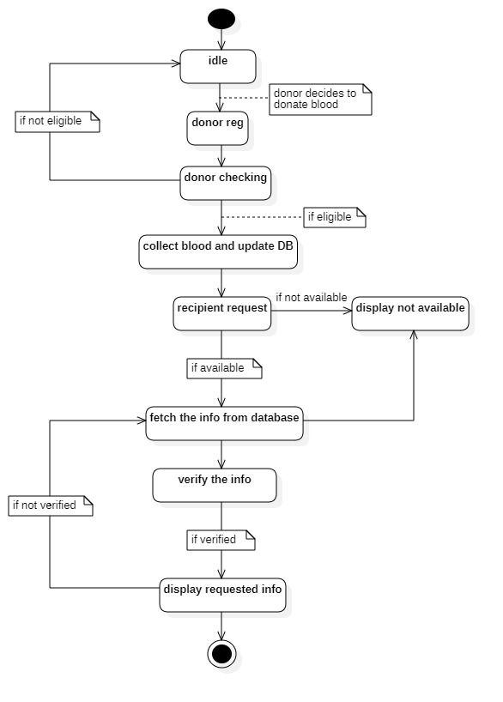

Figure 3.2: Proposed System State chart diagram

## **3.2 Design of the Proposed System**

The Blood Bank Information Management System is a web-based system used by the hospital blood bank or blood center. The system serves as a medium for public to increase their awareness and to promote the importance of blood donation especially in saving lives. The system also provides a few functions for the hospital staff to manage the blood packets and campaign that have been created. This system also has an ability to keep track of donor records and the status of blood stock in the blood bank. Authorized user will collect information about the blood donor like contact and address details for registration and upload into the system. The administrator searches various donors’ details based on normal or map-based search. The administrator can view the account information and can also view the suggestion (feedbacks) given by different users of this site. The administrator can view and be able to do a comprehensive report of the system.

## **3.2.1 Data Model**

Data model is an integrated collection of concepts used for describing data, relationships that exists between data and constraints on data. It is a real-world representation of objects and events, and their association. The primary importance of a data model is to represent data and make data more comprehensive.

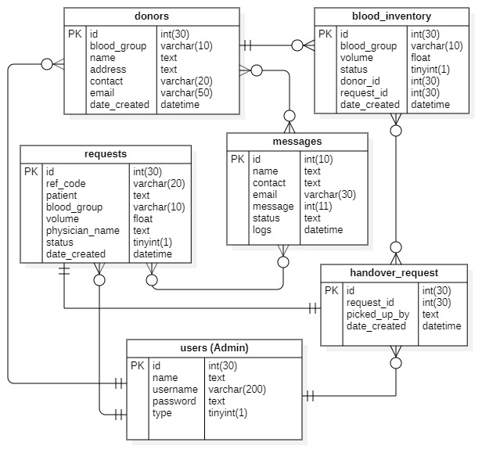

Figure 3.4: Entity Relationship Diagram

The diagram above designed with **StarUML** version 3.2 explains the relationship amongst the various entities present in the database schema.

## **3.2.2 Functional Requirements**

The functional requirements of the blood bank management system refer to what the system should do, as well as the important requirements of the system as seen in the following Use Case Diagram below.

Use case diagram serves as an interaction between users and the system. The use case diagram below illustrates the role of blood donor’s information management system users and how they will be interacting with the system when implemented. UML Use case diagram for Blood Bank Information Management System is shown below. The various participants of the same are detailed below:

**Actors**: - User, Donor and Admin

The corresponding use cases for these actors are:

* **User**: Make request for blood and send feedback.
* **Donor**: Make donation, Send message.
* **Super Administrator/Staff Admin**: Make request for donation, search donor, system management, maintain donation information and basic eligibility.

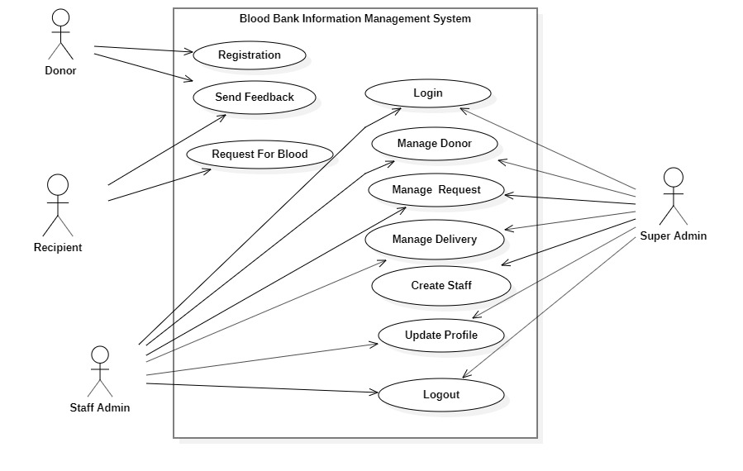

Figure 3.5: Use Case Diagram of the Proposed System

Figure above is the use case diagram of the proposed system the admin would be responsible for managing the entire system (i.e., Manage donor, manage patient request etc.) The donor and the patient at the other hands are regarded as the main users of the system that registers, request for blood, donate blood to patient in need of blood etc.

They include descriptions of the required functions and online details to be held in the system and can further be divided into functional and non-functional description below

**(a) Functional Description of the System Modules**

1. **Admin module:** These are the functionality performed by the admin users.
2. Login for Admin
3. Edit Profile for Admin
4. Change Password for Admin
5. Logout Functionality
6. Dashboard for Admin User
7. **Manage Blood Stock**

* Adding New Blood Stock
* Edit the Exiting Blood Stock
* View details of the Blood Stock
* Listing of all Blood Stock

1. **Manage Donor**
2. Adding New Donor
3. Edit the Exiting Donor
4. View details of the Donor
5. Listing of all Donors
6. **Reports of the project Blood Bank Management System**
7. Report of all Blood Stocks
8. Report of all Donors
9. **Donor Module:** This module provides all the functions related to blood donors. It tracks all the information of the donors. The module is a role-based module premised on CRUD (create, read, update and delete) operations where admin can perform each operation on data but the donor will be able to view only his/her data. Therefore, access level restrictions are implemented. Its features are summarized below:

* Admin can see the list of donor details
* Only admin can edit and update the record of the donor
* Admin will be able to delete the records of the donor
* All donor forms are validated on client side using JavaScript

1. **Blood Stock Module**: This provides all the related functions to blood stock. All blood stock will be managed by admin and users will be able to see blood stock. The features are summarized below:

* Admin can add new blood stock
* Admin can see the list of blood stock details
* Only admin can edit and update the record of the blood stock
* Admin will be able to delete the records of the blood stock
* All blood stock Forms are validated on client side using JavaScript

1. **Statics**

These static pages will be available in Blood Bank Information Management System

* Home Page with good UI
* Home Page will contain an animated slider for images banner
* About us page will be available which will describe about the project
* Contact us page will be available in the project

1. **Technology Used in the Project**

**HTML**: Page layout has been designed in HTML

**CSS:** CSS has been used for all the designing part

**JavaScript:** All the validation task and animations has been developed by JavaScript

**PHP:** All the business and frontend logic has been implemented in PHP

**MySQL:** MySQL database has been used as database for the project

**XAMPP:** Project will be run over the XAMPP server

**(b) Non-functional requirement**

This is a description of system characteristics, such as response, speed, and storage requirements, and are classified into:

**Performance Requirements**: This is a measurement of system’s efficiency and implementation in which the system's response rate must be during a short period of time as well as the system having the ability to host multiple users.

**Safety Requirements:** The is to preserve the system from abusive hands for example following the program of protecting and methods of preserving data such as periodic backups and data retrieval.

**Security Requirements:** Protect your data by logging into the system with your username and password in order to prevent unauthorized access.

**Database Design**

This section focuses attention on design of data storage component of the system (database in practice). Database is concerned with how data is stored, handled and retrieved by the program (processes) that run in the systems. Relational database is used and is based on the collection of tables each of which has a primary key (key fields) whose value is from any row of the table and it uniquely identifies a tuple. The tables are related to one another by placement of key from one into the related table as a foreign key i.e., where the primary key is referenced in another table. It is called the foreign key. In this work, the database management system used is MYSQL. This is chosen because its support for referential integrity. The database for this system is named bloodbank_db and it consists of the following tables with the table description. The database design of the system is presented in Table 1 to Table 7 below.

Table 3.1: User Table

|  |  |  |  |
| --- | --- | --- | --- |
| **Name** | **Type** | **Null** | **Key** |
| User Id | Int (30) | No | Primary |
| Name | Text | No |  |
| Username | Varchar (50) | No |  |
| Password  Type | Varchar (50)  Tinyint (1) | No  No |  |

Table 3.2: Donor Table

|  |  |  |  |
| --- | --- | --- | --- |
| **Name** | **Type** | **Null** | **Key** |
| Donor Id | Int (30) | No | Primary |
| Name | Text | - |  |
| Blood group | Varchar (10) | - |  |
| Address | Text | - |  |
| Contact | Varchar (20) | - |  |
| Email  Date created | Varchar (50)  Datetime | -  - |  |

Table 3.3: Request Table

|  |  |  |  |
| --- | --- | --- | --- |
| **Name** | **Type** | **Null** | **Key** |
| Request Id | Int (30) | No | Primary |
| Reference Code | Varchar (20) | - |  |
| Patient name | Text | - |  |
| Blood group | Varchar (10) | - |  |
| Volume | Float | - |  |
| Physician name  Status  Date created | Text  Tinyint (1)  Datetime | -  -  - |  |

Table 3.4: Blood Inventory Table

|  |  |  |  |
| --- | --- | --- | --- |
| **Name** | **Type** | **Null** | **Key** |
| Blood Id | Int (30) | No | Primary |
| Blood group | Varchar (10) | - |  |
| Volume | Float | - |  |
| Donor Id | Int (30) | - | Foreign |
| Request Id  Date created | Int (30)  Datetime | -  - | Foreign |

Table 3.5: Handover Request Table

|  |  |  |  |
| --- | --- | --- | --- |
| Name | Type | Null | Key |
| Handover RQ Id | Int (30) | No | Primary |
| Request Id | Int (30) | - | Foreign |
| Picked up by  Date created | Text  Datetime | -  - |  |

Table 3.6: Message Table

|  |  |  |  |
| --- | --- | --- | --- |
| **Name** | **Type** | **Null** | **Key** |
| Message Id | Int (10) | No | Primary |
| Name | Text | - |  |
| Contact | Text | - |  |
| Email | Varchar (50) | - |  |
| Message  Status  Logs | Text  Text  Datetime | -  -  - |  |

## **3.2.3 System Architecture**

A system architecture is the [conceptual model](https://en.wikipedia.org/wiki/Conceptual_model) that defines the [structure](https://en.wikipedia.org/wiki/Structure), [behavior](https://en.wikipedia.org/wiki/Behavior), and more [views](https://en.wikipedia.org/wiki/View_model) of a [system](https://en.wikipedia.org/wiki/System).  An architecture description is a formal description and representation of a system, organized in a way that supports reasoning about the [structures](https://en.wikipedia.org/wiki/Structure) and [behaviors](https://en.wikipedia.org/wiki/Behavior) of the system. A system architecture can consist of system [components](https://en.wikipedia.org/wiki/System) and the sub-systems developed, that will work together to implement the overall system. There have been efforts to formalize languages to describe system architecture, collectively these are called [architecture description languages](https://en.wikipedia.org/wiki/Architecture_description_languages) (ADLs). The proposed system utilizes a three-tier client server architecture. Client-server model is based on distribution of tasks or roles between two types of independent and autonomous processes or systems. A client is any system, subsystem or process that provides requested service(s) for the client. Both the client and server processes can reside in same computer or in different computers linked by a network.

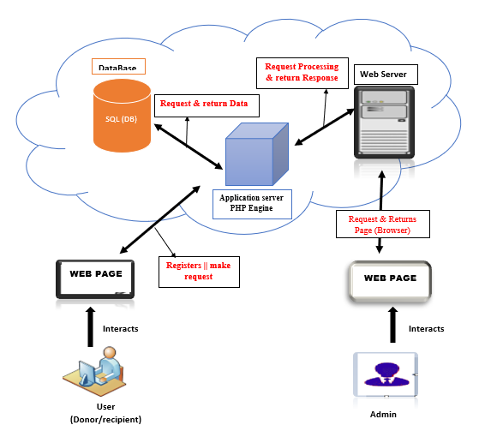

Figure 3.6: Deployment Diagram.

The figure above shows the application user (client) with the system via a blood bank information management system and a web browser respectively. Requests from the user is parsed in PHP engine and thereafter sent to the database server for persistence. The application user (client) requests information from the web server through a HTTP connection and also the administrator also communicates through an interface to the webserver. Here, there is a two-way connection or communication between the client and the server which facilitates quick response to requests by the clients.

## **3.2.4 Software Architecture**

Software architecture refers to the fundamental structures of a software and the discipline of creating structures and systems. Each structure comprises of software elements, relations among them and properties of both elements and relations. Software architecture is about making fundamental structural choices that are costly to change once implemented. Software architecture choices include specific structural options from possibilities.

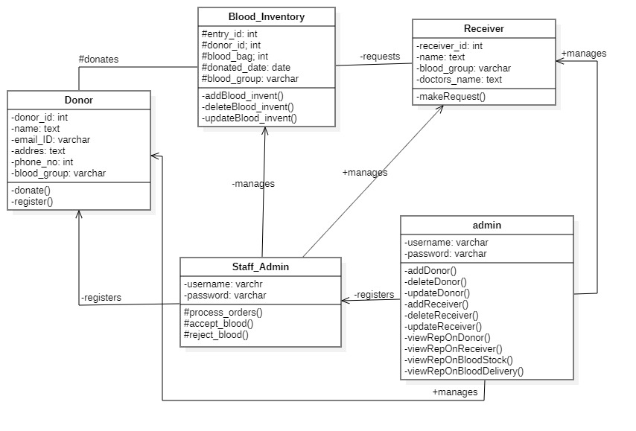

Figure 3.7: Class Diagram.

## **3.2.5 Workflow of Use Cases**

Workflow of Use cases shows the process of how to accomplish a task of making a report or raising an alert. This illustrates the activities diagrammatically of what the application does at a particular point in time towards achieving an end result.

Activity diagrams are graphical representations of workflows of stepwise activities and actions with support for choice, iteration and concurrency. Activity diagrams show the procedural flow of control between class objects, along with organizational processes like business workflows. The diagrams below illustrate the activity diagram of blood bank management system which shows the flows of the login activity, where the administrator will be able to login using their username and password. After login the admin can manage all the operations on blood stock, Donor data, patient request. The diagram illustrates how the login page works in a blood bank management system. The various objects in the donor blood stock and request page interact over the course of the activity.

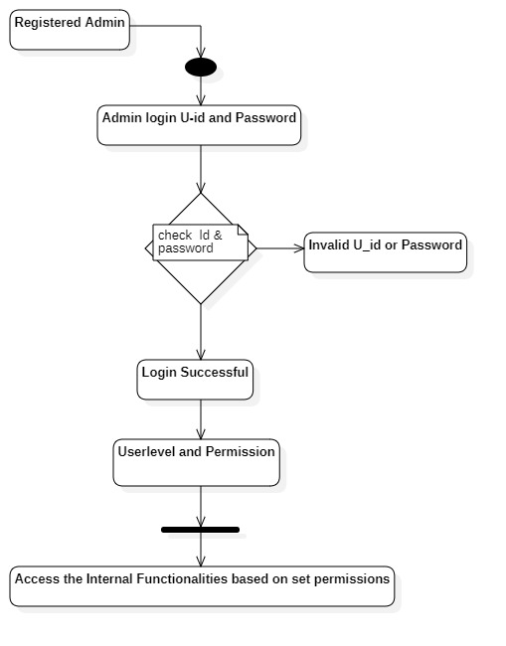

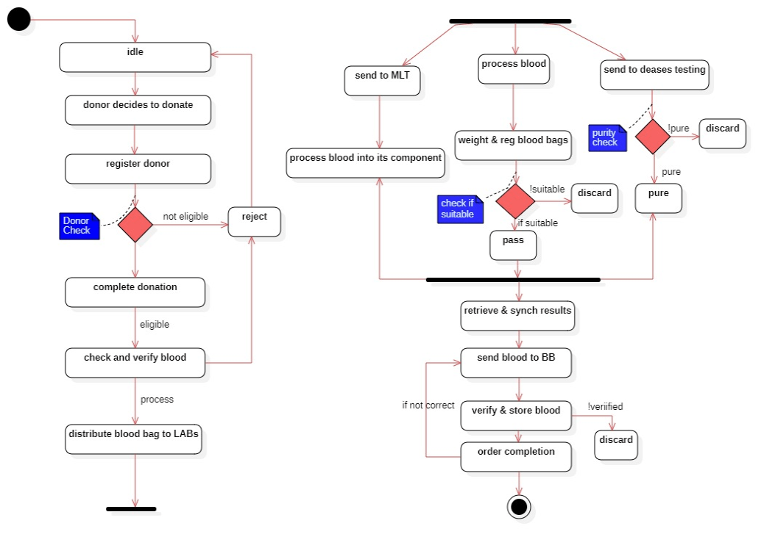

Figure 3.7: Activity Diagram.

Figure 3.7 shows the continuation of the activity flow. The diagram illustrates how blood is collected from donors right after a decision is made to donate, the process testing and centrifugation, and then distributed based on request from patients after the whole process of verification in the blood bank.

# **CHAPTER FOUR**

## **IMPLEMENTATION AND DISCUSSION**

**Introduction**

This chapter presents the results of the experimental setup as envisaged in chapter three. The chapter further implements and discusses the findings of the study.

## **4.1 System Requirement for Development**

Software environment is a technical specification of requirement of software product. This specifies the environment for development, operation and maintenance of the product. The system requirement for development of the blood bank information management system therefore is hinged on the following:

## **4.1.1 Technology used**

**XAMPP Control Panel V3.2.2:** This is an abbreviation for cross-platform, Apache, MySQL, PHP and Perl, and it allows one to build sites offline, on a local web serve on a computer. This simple lightweight solution works on Windows, Linux and Mac hence, the cross-platform part. In other words, XAMPP is a software distribution which provides the Apache web server, MySQL database (actually MariaDB), PHP and Perl (as command-line executables and Apache modules) all in one package.

**MySQL:** MySQL is a RDBMS (Relational Database Management System), PhpMyAdmin is a web application which let you manage (with a visual interface) MySQL Databases. MYSQL is the most popular database server and PhpMyAdmin is a web-based administrating tool for MYSQL. PhpMyAdmin helps you to view the databases and tables and their data in a neat form and makes your life easy.

**PHP**

PHP is a general-purpose scripting language especially suited to web development. It was originally created by Danish-Canadian programmer Rasmus Lerdorf in 1994. The PHP reference implementation is now produced by The PHP Group.

**HTML**

HTML stands for Hyper Text Markup Language. HTML is the standard markup language for creating Web pages. HTML describes the structure of a Web page. HTML consists of a series of elements. HTML elements tell the browser how to display the content. The Hypertext Markup Language, or HTML is the standard markup language for documents designed to be displayed in a web browser. It can be assisted by technologies such as Cascading Style Sheets and scripting languages such as JavaScript. HTML (Hypertext Markup Language) is the code that is used to structure a web page and its content. For example, content could be structured within a set of paragraphs, a list of bulleted points, or using images and data tables.

**Cascading Style Sheets** (**CSS**)

Cascading Style Sheets (CSS) is a [style sheet language](https://en.m.wikipedia.org/wiki/Style_sheet_language) used for describing the [presentation](https://en.m.wikipedia.org/wiki/Presentation_semantics) of a document written in a [markup language](https://en.m.wikipedia.org/wiki/Markup_language) such as [HTML](https://en.m.wikipedia.org/wiki/HTML). CSS is a cornerstone technology of the [World Wide Web](https://en.m.wikipedia.org/wiki/World_Wide_Web), alongside HTML and [JavaScript](https://en.m.wikipedia.org/wiki/JavaScript). CSS is designed to enable the separation of presentation and content, including [layout](https://en.m.wikipedia.org/wiki/Page_layout), [colors](https://en.m.wikipedia.org/wiki/Color), and [fonts](https://en.m.wikipedia.org/wiki/Typeface). This separation can improve content [accessibility](https://en.m.wikipedia.org/wiki/Accessibility), provide more flexibility and control in the specification of presentation characteristics, enable multiple [web pages](https://en.m.wikipedia.org/wiki/Web_page) to share formatting by specifying the relevant CSS in a separate .css file which reduces complexity and repetition in the structural content as well as enabling the .css file to be [cached](https://en.m.wikipedia.org/wiki/Cache_(computing)) to improve the page load speed between the pages that share the file and its formatting. Separation of formatting and content also makes it feasible to present the same markup page in different styles for different rendering methods, such as on-screen, in print, by voice (via speech-based browser or [screen reader](https://en.m.wikipedia.org/wiki/Screen_reader)), and on [Braille-based](https://en.m.wikipedia.org/wiki/Braille_display) tactile devices. CSS also has rules for alternate formatting if the content is accessed on a [mobile device](https://en.m.wikipedia.org/wiki/Mobile_device).

The name *cascading* comes from the specified priority scheme to determine which style rule applies if more than one rule matches a particular element. This cascading priority scheme is predictable. CSS facilitates publication of content in multiple presentation formats based on nominal parameters. Nominal parameters include explicit user preferences, different web browsers, the type of device being used to view the content (a desktop computer or mobile device), the geographic location of the user and many other variables.

**JavaScript**

JavaScript, often abbreviated as JS, is a programming language that conforms to the ECMAScript specification. JavaScript is high-level, often just-in-time compiled, and multi-paradigm. It has curly-bracket syntax, dynamic typing, prototype-based object-orientation, and first-class functions. JavaScript is a scripting programming language that allows the implementation of complex features on web pages. These include implementing dynamically interactive content updates, interactive maps, animated 2D/3D graphics, scrolling video, jukeboxes, control multimedia, animate images, chart box etc.

## **4.1.2 Hardware Requirements**

Similarly, for the effective operation of the newly designed system, the following minimum hardware specifications are recommended:

1. Personal Computer (PC)
2. Minimum 2GB of RAM. But 6GB of RAM and above is recommended.
3. 1.8 GHz or faster processor
4. The mouse, keyboard and printer are optionally required.

The above-listed system configurations are the minimum requirements, but if the configurations are of higher versions, the processing speed is greatly improved.

## **4.2 System Menus Implementation**

This section unveils all the functional interfaces of the proposed system with their appropriate screenshots discussed in the following sections as follows:

**A. Section One**

## **4.2.1 The Home Page**

The home page is the main web page of the website. The term is also referred to one or more pages always shown in a web browser when the application starts up. It is also known as the start page. The homepage of the BBIMS provides the main page where visitors can find hyperlinks to other pages on the site. By default, the homepage is index.php. It contains hyperlinks such as Digital blood banking, About, Services, become a Donor, Make Request, Camps and Contact us.

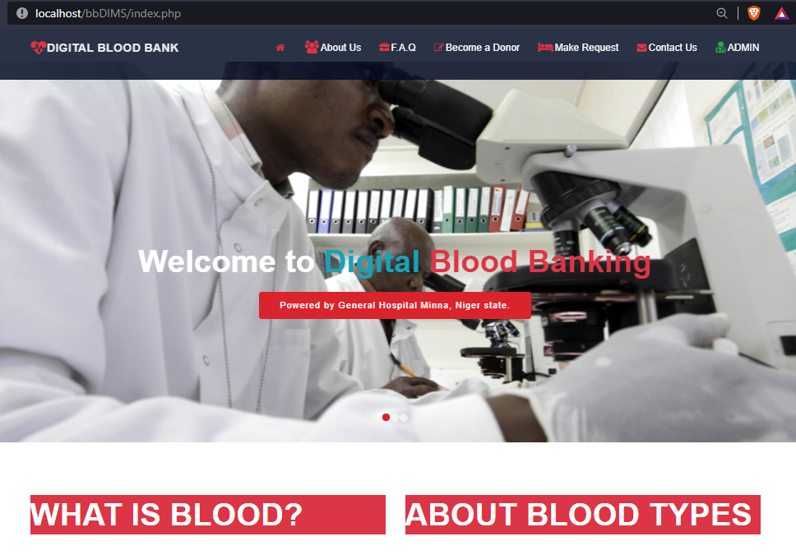

Fig. 4.1: The Home Page of the system

## **4.2.2 The About Page**

The “About” section is often the most overlooked aspect of a website. The focus is put on services and products, as these are the pages which most often affect search engine results. The About page shows the users the brief history of a company or organization. The overall purpose of a website is to provide enough useful information to convert a web visitor into a potential lead or customer, and the “About” section is often the best place to make this happen. The About page of this website therefore answer questions about the blood donation system.

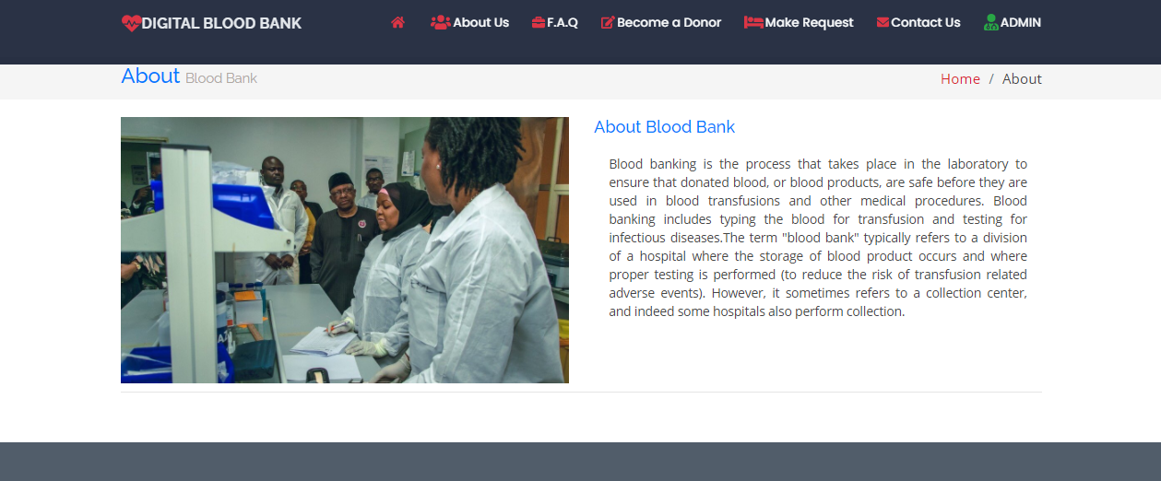

Fig. 4.2: The About interface of the system

## **4.2.3 The Frequently Asked Question page**

The F.A.Q is another very important page found on the system. It contains vital information concerning questions relating to blood banking. The **F.A.Q** contains information on the general guidelines on donating, the importance of donating, how to make a request for blood in the hospital and

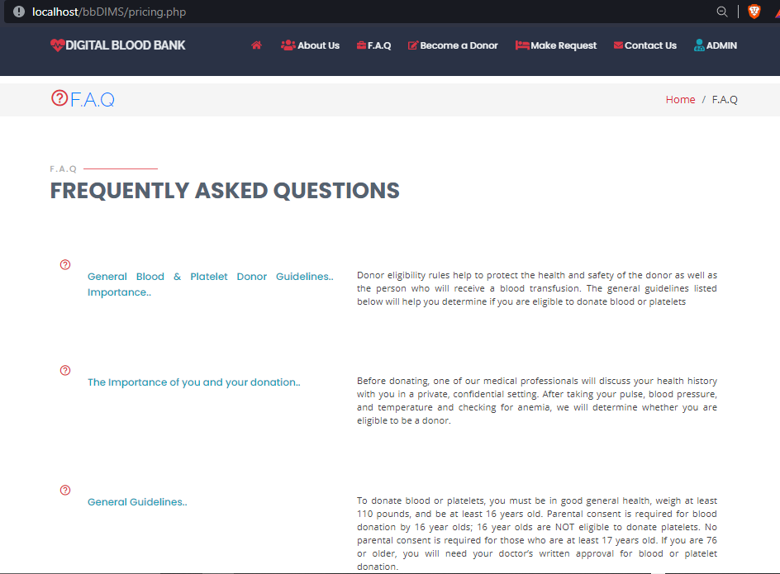

Figure 4.3: The Frequently Asked Question page

## **4.2.4 The Contact page**

This is also one of the key functionalities found on the system. It is also one of the transaction options responsible for getting hold of the customer’s service comments or feedback. The **Contact us page** is the go-to for a new visitor on a mission. It is where they go when they have a question and truly want to speak to an individual or make comments, feedback or request. This page exists to serve the user with the purpose of providing them with information on how they can get in touch with the Administrator or management of the hospital. This could be voluntarily, donate blood or make orders for blood. On this page, a visitor can send a message or call.

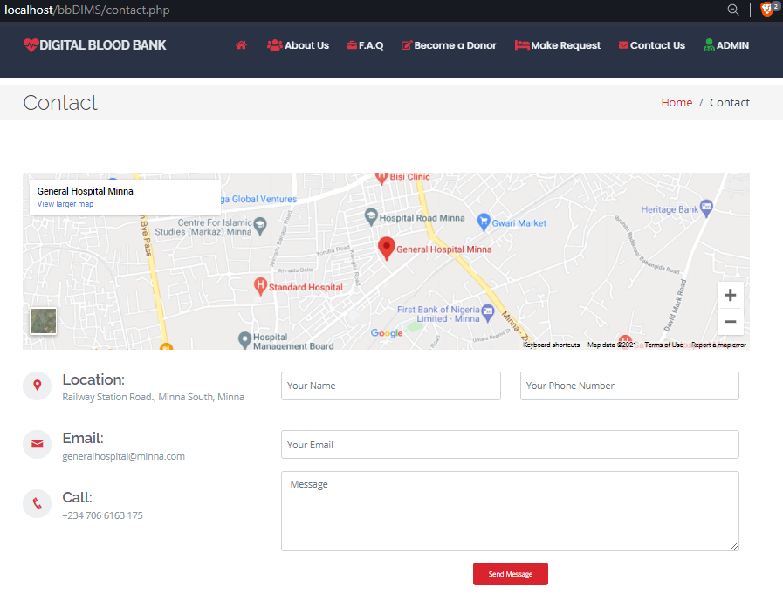

Figure 4.4: The Contact page

## **4.2.5 The New Donor Registration Page**

This page provides a form which is a list of fields that a user will input data into and submit to the administrator. This registration forms can be used to sign up a customer for subscriptions, services or other programs or plants. Specifically, the page provides an opportunity for voluntary blood donors to register so that they can be given appointment to the hospital to donate blood.

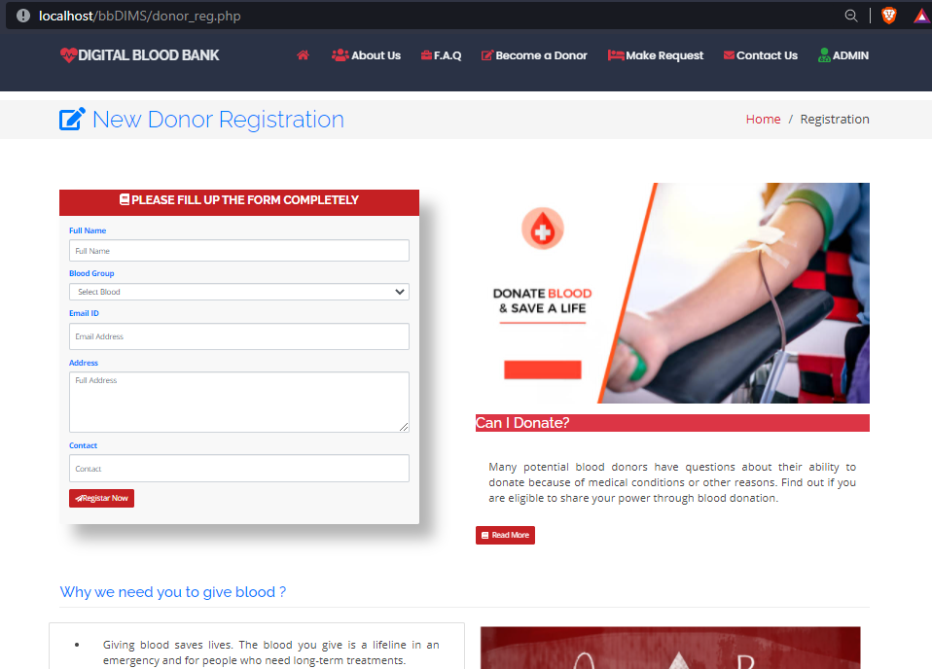

Figure 4.5: The New Donor Registration Page

## **4.2.6 Request for Blood Form**

This page allows patients to request for blood. The patient can fill his/her name, the quantity of blood requesting for, blood group and doctor’s name.

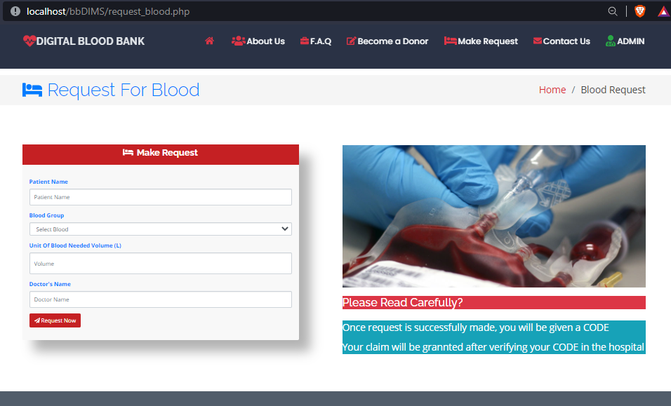

Figure 4.6: The Request for Blood Form

**B. Section Two**

## **4.2.7 The Admin Side of the Site**

The admin side of the website provides the Content Management System (CMS). The Admin Panel is used to manage and operate the CMS. It is like the engine is the CMS and the steering wheel is the Admin Panel. The Admin Panel has the following panels under it: Blood Donations, Blood Donors, Blood Request, Deliveries, Home and Users.

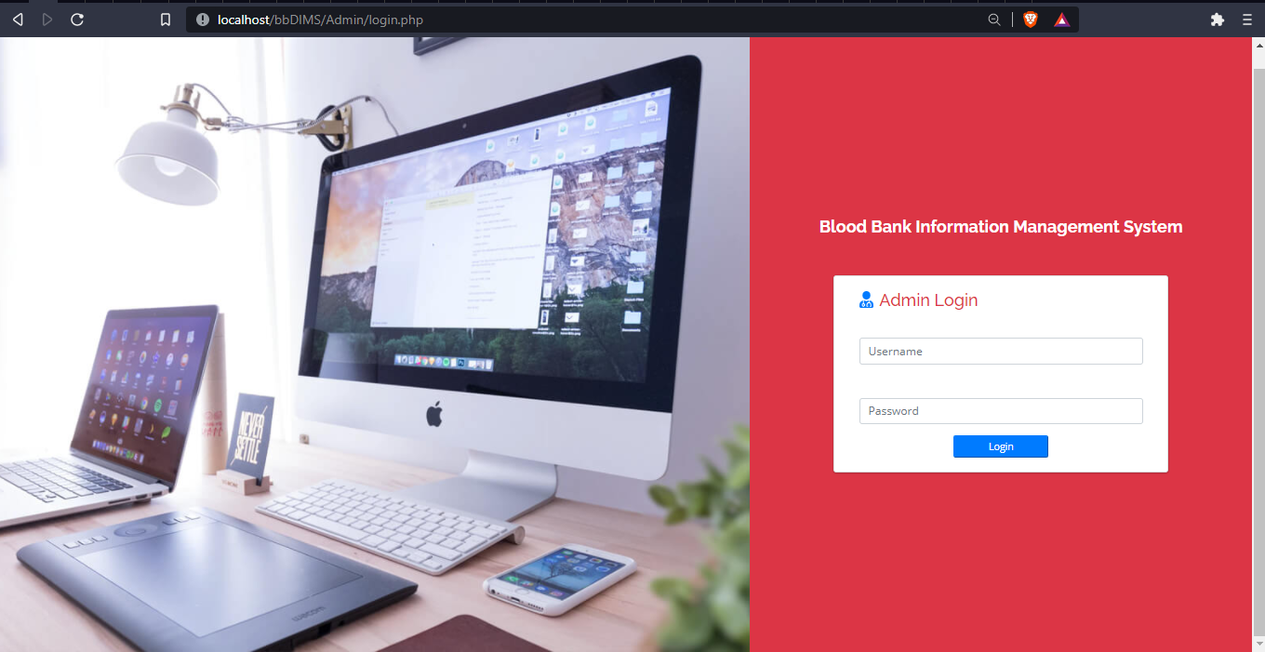

Figure 4.7: The Admin Login Panel

### **4.2.7.1 Home**

This is the Dashboard panel for the Administrators. It records and shows the available blood per group in liters. This also records the total number of donors, total donated in a day, requests for blood made in a day and requests approved in a day.

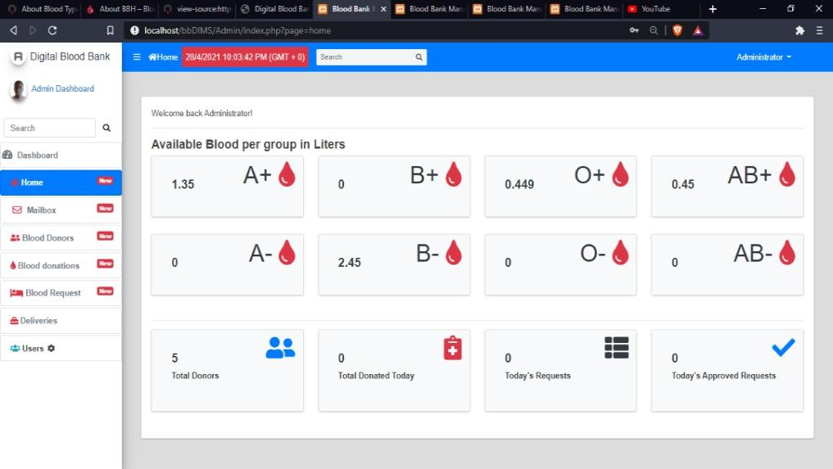

Figure 4.8: The Admin Home Panel

### **4.2.7.2 Blood Donors**

This panel keeps record of blood donors. It records the donor’s names, blood group, information (contact details) and previous donations.

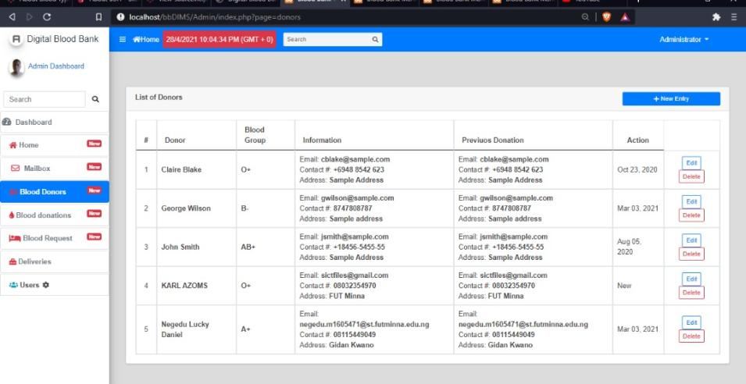

Figure 4.9: The Admin Blood Donors Panel

### **4.2.7.3 Blood Donations**

This panel records blood donation entries. It records the date a donation was made, the donor, blood group of donor and volume(ml) made.

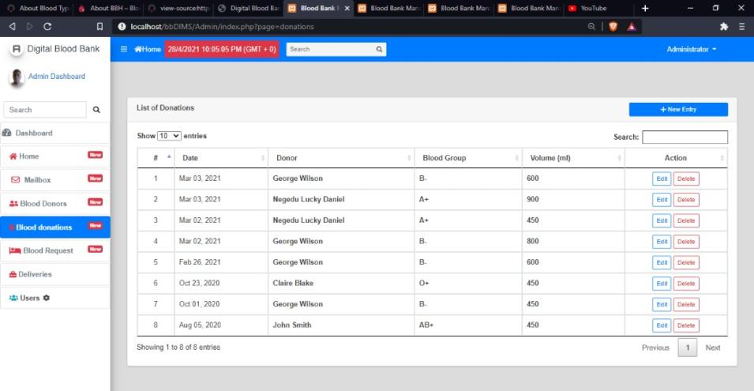

Figure 4.10: The Admin Blood Donation Panel

### **4.2.7.4 The Admin Users Panel**

This panel records the entries of users of the system. It keeps track of the administrators’ name, username and admin privileges (type).

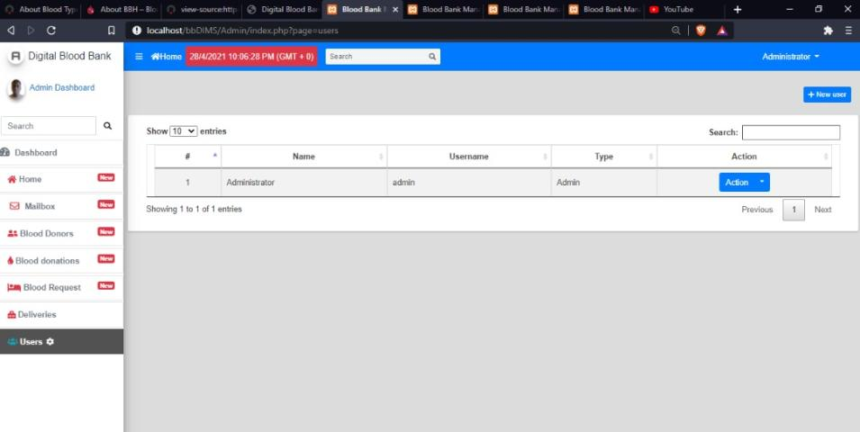

Figure 4.11: The Admin User Panel

### **4.2.7.5 The Admin Blood Request Deliveries Panel**

This panel records the delivery of blood requests made. It records the date deliveries are made, request’s reference code, patient’s name and blood group. It also keeps record of information regarding the volume of blood delivered and the recipient of the delivery.

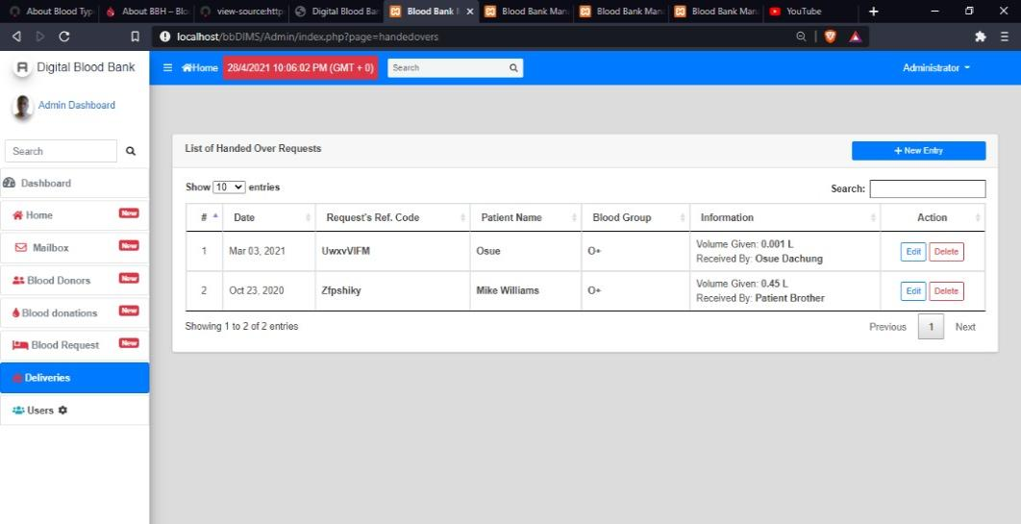

Figure 4.12: The Admin Blood Delivery Panel

## **4.3 Database Implementation**

This section focuses attention on the implementation of data storage component of the system. Database is concerned with how data is stored, handled and retrieved by the program (processes) that run in the systems. Relational database is used and is based on the collection of tables each of which has a primary key (key fields) whose value is from any row of the table and it uniquely identifies a tuple. The tables are related to one another by placement of key from one into the related table as a foreign key i.e., where the primary key is referenced in another table. It is called the foreign key. In this work, the database management system used is MYSQL.

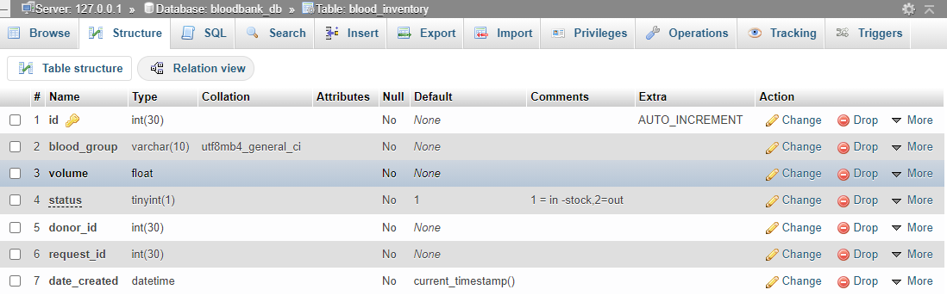

Figure 4.13: Blood Inventory Table

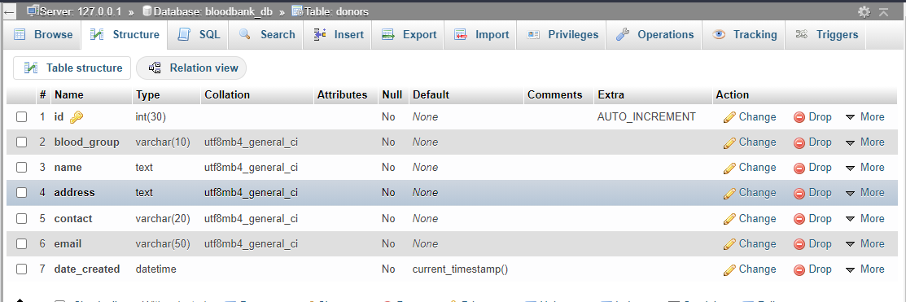

Figure 4.14: Donors Table

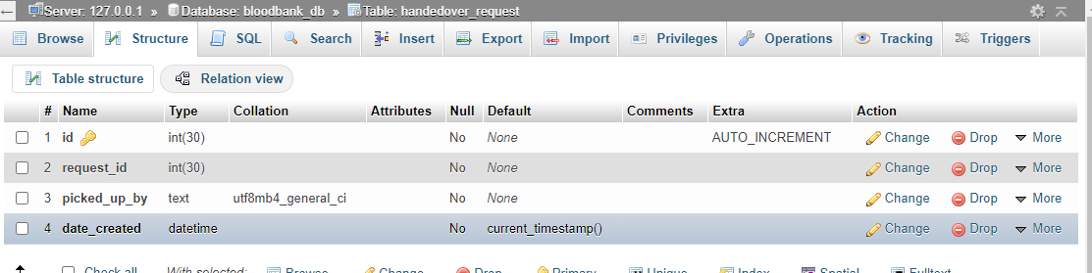

Figure 4.15: Handover Request Table

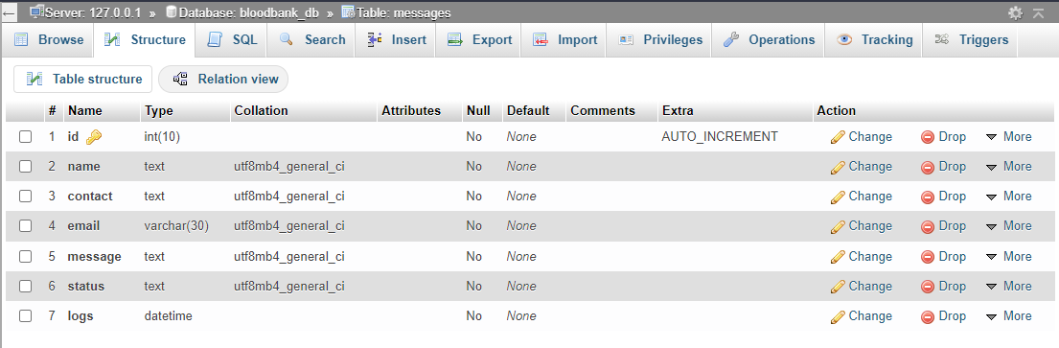

Figure 4.16: Messages Table

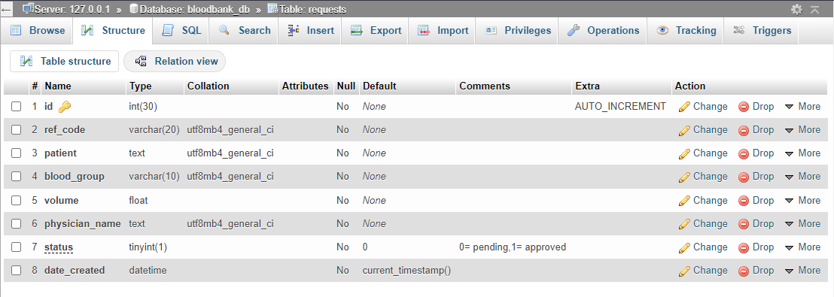

Figure 4.17: Request Table

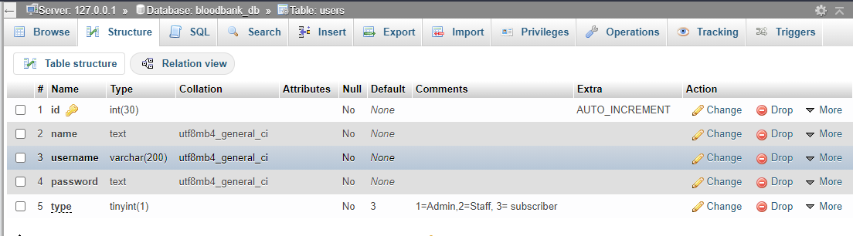

Figure 4.18: Users Table

## **4.4 System Testing**

This is a testing procedure that uses real data, which the system is intended to manipulate, to test the system. Firstly, all the subsystems will be integrated into one system, thereafter, the system as a whole will be tested using a variety of data to see the intended overall results. Usually, this test is conducted when the system is about to be deployed in a production environment. The deployment is a mere replication of the tested system into production servers but tests on production environment have to be done to make sure everything is running.

System testing for the application follows the underlines processes:

Table 4.1: System Testing Results

|  |  |  |
| --- | --- | --- |
| S/N | System Testing | Results |
| 1. | Install the system into server. | Pass |
| 2. | Start up all servers such as MySQL database server. | Pass |
| 3. | Run tests by using real data on all test cases | Pass |

# **CHAPTER FIVE**

## **CONCLUSION AND RECOMMENDATIONS**

**Introduction**

This chapter concludes this study. A summary of the research is presented. The significance of this research is examined. Recommendations for further research is suggested in the end of this chapter.

## **5.1 Conclusion**

Blood donation and transfusion differs throughout the world. Notwithstanding, the most important aspects in the organization of blood donation and transfusion is cooperation, communication, care and safety for donors and patients. Problems arises when there is lack of blood and there is so much demand for same. People begin to search for where the blood fictions are readily available and this becomes very difficultto get blood easily.

More so, in emergency surgery situations, it becomes very difficult to get some rare fictions. This research has therefore developed the BBIMS to enable blood donors and blood needing patients to source for blood fictions in hospitals. The goal is to provide blood to the people who are in need of blood. The number persons who are in need of blood are increasing in large number day by day. Using this system, users can search blood group if available in the city and he can also get contact number of the donor who has the same blood group needs. This electronic blood bank information management system can be effectively used to get any available blood group.

We can conclude therefore that, all functions requirement raised from the objective to solve the proposed problem have been developed in this project. Further steps should be carried on to activate this implemented solution such as entering real data. It is important to properly management blood bank information in hospitals using easily and readily available technologies while minimizing costs and time.

## **5.2 Recommendation**

Experimental results show the usefulness of the automated system in eliminating most of the errors and hindrances that ensue from paperwork. This system is therefore recommended for hospitals to enable them reduce the complexity of manual work. As research and development is a continuous process so it is in computer and software development. This system will be useful since it is computerized and will promote effective, efficient and improve service delivery. The employment of computer personnel for effective maintenance of the system will enhance the maximum output of this package and the use of computer in blood inventory system. Adopting this system, the following should be taken into consideration, training of staff, security measures, and the provision of dependable real-time processing system for speedy responses.

For future work, someone with interest in this research topic can develop a mobile application that caters for the system’s full functionalities.

# **REFERENCES**

Ali, K. M. A., Jahan, I., Islam, A., & Parvez, S. (2015). *American Journal of Engineering Research (AJER) Blood Donation Management System*. *6*, 123–135.

Alkandari, A., & Alkandari, A.A. (2016). BLOOD BANK SMART PHONE APPLICATION FOR MANAGING AND ORGANIZING THE BLOOD DONATION. International journal of new computer architectures and their applications, 6, 86-91.

Angeline, R., Mishra, R. D., Gopalakrishnan, L., & Saravanan, B. (2019). *An GPS Based Online Blood Bank Management using Database Management System*. *1*, 448–452. https://doi.org/10.35940/ijitee.A4183.119119

Anifowoshe, A. T., Owolodun, O. A., Akinseye, K. M., Iyiola, O. A., & Oyeyemi, B. F. (2017). Gene frequencies of ABO and Rh blood groups in Nigeria: A review. *Egyptian Journal of Medical Human Genetics*, *18*(3), 205–210. https://doi.org/10.1016/j.ejmhg.2016.10.004

Barrientos-Soto, M. C., Castañeda-García, M., Herrera-García, A., Padilla-López, S., Dimas-Adame, M. A., & Cazares-Tamez, R. (2017). The use of DTT in the resolution of the interferences generated by daratumumab in the blood bank. *Medicina Universitaria*, *19*(76), 127–130. https://doi.org/10.1016/j.rmu.2017.07.006

Bello-López, J. M., Castañeda-García, C., Muñoz-Estrada, C., & Machorro-Peréz, A. J. (2018). External quality control program in screening for infectious diseases at blood banks in Mexico. *Transfusion and Apheresis Science*, *57*(1), 97–101. https://doi.org/10.1016/j.transci.2018.01.004

Bru, G., & Piccolo, C. (2018). PT US CR. *Omega*. https://doi.org/10.1016/j.omega.2018.09.006

By, S., Sharma, B. N., Pandey, G., To, S., & Timalsina, A. (n.d.). *Blood bank management system*.

Ezugwu, A. E., Olusanya, M. O., & Govender, P. (2019). Mathematical model formulation and hybrid metaheuristic optimization approach for near-optimal blood assignment in a blood bank system. *Expert Systems with Applications*, *137*, 74–99. https://doi.org/10.1016/j.eswa.2019.06.059

Hamdan, B., & Diabat, A. (2020). Robust design of blood supply chains under risk of disruptions using Lagrangian relaxation. *Transportation Research Part E: Logistics and Transportation Review*, *134*(July 2019), 101764. https://doi.org/10.1016/j.tre.2019.08.005

Hamdan, B., & Diabat, A. (2020). Robust design of blood supply chains under risk of disruptions using Lagrangian relaxation. *Transportation Research Part E: Logistics and Transportation Review*, *134*(July 2019), 101764. https://doi.org/10.1016/j.tre.2019.08.005

Jaques, B., Saldanha, P. C. de A., & Moraes, A. C. R. de. (2019). Profile of blood donations with a positive serology in Southern Brazil. *Hematology, Transfusion and Cell Therapy*, *x x*, 5–9. https://doi.org/10.1016/j.htct.2019.05.007

Kuopio, T., Heart, I., Risk, D., & Study, F. (1998). *Donation of Blood Is Associated with Reduced Risk of Myocardial Infarction*. *148*(5), 445–451.

Li, B. N., & Chao, S. (2008). *On decision making support in blood bank information systems*. *34*, 1522–1532. https://doi.org/10.1016/j.eswa.2007.01.016

Lowalekar, H., & Ravi, R. R. (2017). Revolutionizing blood bank inventory management using the TOC thinking process: An Indian case study. *International Journal of Production Economics*, *186*, 89–122. https://doi.org/10.1016/j.ijpe.2017.02.003

Morris, D., Hoving, D. Van, Stander, M., Bruijns, S., Medicine, E., Town, C., & Africa, S. (2019). African Journal of Emergency Medicine Utilisation of emergency blood in a cohort of South African emergency centres with no direct access to a blood bank. *African Journal of Emergency Medicine*, *9*(3), 114–118. https://doi.org/10.1016/j.afjem.2019.01.017

Mostafa, A. M., & Youssef, A. (2014). *A Framework for a Smart Social Blood Donation System Based on Mobile Cloud*. *March 2016*. https://doi.org/10.5121/hiij.2014.3401

Najafi, M., Ahmadi, A., & Zolfagharinia, H. (2017). Blood inventory management in hospitals: Considering supply and demand uncertainty and blood transshipment possibility. *Operations Research for Health Care*, *15*, 43–56. https://doi.org/10.1016/j.orhc.2017.08.006

Nwogoh, B., Aigberadion, U., & Nwannadi, A. I. (2013). *Knowledge, Attitude, and Practice of Voluntary Blood Donation among Healthcare Workers at the University of Benin Teaching Hospital, Benin City, Nigeria*. *2013*.

Ok, O., Om, U., & Al, O. (2020). *Current Trend in Blood Transfusion Science, where are we?* https://doi.org/10.23880/hij-16000159

Patel, R. S. (n.d.). *Submitted To: Submitted By: Internal Guide:* *13084231181*.

Sahid Ramadhan, M. N., Amyus, A., Fajar, A. N., Sfenrianto, S., Kanz, A. F., & Mufaqih, M. S. (2019). Blood Bank Information System Based on Cloud Computing in Indonesia. *Journal of Physics: Conference Series*, *1179*(1). https://doi.org/10.1088/1742-6596/1179/1/012028

Selvamani, K., & Kumar Rai, A. (2015). A novel technique for online blood bank management. *Procedia Computer Science*, *48*(C), 568–573. https://doi.org/10.1016/j.procs.2015.04.137

Selvamani, K., & Rai, A. K. (2015). A Novel Technique for Online Blood Bank Management. *Procedia - Procedia Computer Science*, *48*(Iccc), 568–573. https://doi.org/10.1016/j.procs.2015.04.137

Sulaiman, S., Abdul Hamid, A. A. K., & Najihah Yusri, N. A. (2015). Development of a Blood Bank Management System. *Procedia - Social and Behavioral Sciences*, *195*, 2008–2013. https://doi.org/10.1016/j.sbspro.2015.06.215

Testing, P. (2018). *Blood bank testing 4*. https://doi.org/10.1016/B978-0-12-814313-1/00004-6

# **APPENDIXES**

**View Section**

<!DOCTYPE html>

<html lang="en">

<head>

<meta charset="utf-8">

<meta content="width=device-width, initial-scale=1.0" name="viewport">

<title>Digital Blood Banking System</title>

<meta content="" name="description">

<meta content="" name="keywords">

<!-- Favicons -->

<link href="assets/img/favicon" rel="icon">

<link href="assets/img/apple-touch-icon" rel="apple-touch-icon">

<script src="https://kit.fontawesome.com/a076d05399.js"></script>

<!-- Template Main CSS File -->

<link href="assets/css/style.css" rel="stylesheet">

</head>

<body>

<div class="container d-flex navbar navbar-expand-lg navbar-light">

<div class="navbar-header">

<button type="button" class="navbar-toggle" data-toggle="collapse" data-target="#bs-example-navbar-collapse-1">

<span class="sr-only">Toggle navigation</span>

<span class="icon-bar"></span>

<span class="icon-bar"></span>

<span class="icon-bar"></span>

</button>

</div>

<h1 class="logo me-auto"><a href="index.php">

<i class="fa fa-heartbeat fa-lg text-danger"></i>Digital Blood Bank</a></h1>

<!-- Uncomment below if you prefer to use an image logo -->

<!-- <a href="index.html" class="logo"><img src="assets/img/logo.png" alt="" class="img-fluid"></a>-->

<nav class="nav-menu ml-auto">

<ul class="hea">

<li class=""><a href="index.php" class=""><i class="fa fa-home mr-1 text-danger"></i></a></li>

<li class=""><a href="about.php" class=""><i class="fa fa-users mr-1 fa-lg text-danger"></i>About Us</a></li>

<li class="hea"><a href="pricing.php" class=" "><i class=" fa fa-briefcase mr-1 text-danger"></i>F.A.Q</a></li>

<li><a href="donor_reg.php" class=""><i class="fa fa-edit mr-1 text-danger"></i>Become a Donor</a></li>

<li><a href="request_blood.php" class=""><i class="fa fa-bed fa-lg mr-1 text-danger"></i>Make Request</a></li>

<li><a href="contact.php" class=""><i class="fa fa-envelope mr-1 text-danger"></i>Contact Us</a></li>

<li><a href="Admin/login.php" class=""><i class="fa fa-user-md mr-1 fa-lg text-success"></i>ADMIN</a></li></a></li>

</ul>

</nav><!-- .nav-menu -->

</div>

</header><!-- End Header -->

**Login Section**

<main *id*="main" *class*=" bg-danger">

        <div *id*="login-left">

        </div>

        <div *id*="login-right" *class*="bg-danger">

            <div *class*="w-100">

                <h4 *class*="text-white text-center"><b><?php echo $_SESSION['system']['name'] ?></b></h4>

                <br>

                <br>

                <div *class*="card col-md-8">

                    <div *class*="card-body">

                        <form *id*="login-form">

                            <div *class*="form-group">

                                <label *for*="username" *class*="control-label">Username</label>

                                <input *type*="text" *id*="username" *name*="username" *class*="form-control">

                            </div>

                            <div *class*="form-group">

                                <label *for*="password" *class*="control-label">Password</label>

                                <input *type*="password" *id*="password" *name*="password" *class*="form-control">

                            </div>

                            <center><button *class*="btn-sm btn-block btn-wave col-md-4 btn-primary">Login</button></center>

                        </form>

                    </div>

                </div></div>  </div></main>

**Query section**

<?php

session_start();

ini_set('display_errors', 1);

class Action

{

    private $db;

    public function __construct()

    {

        ob_start();

*include* 'db_connect.php';

*$this*->db = $conn;

    }

    function __destruct()

    {

*$this*->db->close();

        ob_end_flush();

    }

    function login()

    {

        extract($_POST);

        $qry = *$this*->db->query("SELECT * FROM users where username = '" . $username . "' and password = '" . md5($password) . "' ");

*if* ($qry->num_rows > 0) {

*foreach* ($qry->fetch_array() as $key => $value) {

*if* ($key != 'passwors' && !is_numeric($key))

                    $_SESSION['login_' . $key] = $value;

            }

*return* 1;

        } *else* {

*return* 3;  } }

    function login2()

    {

        extract($_POST);

*if* (isset($email))

            $username = $email;

        $qry = *$this*->db->query("SELECT * FROM users where username = '" . $username . "' and password = '" . md5($password) . "' ");

*if* ($qry->num_rows > 0) {

*foreach* ($qry->fetch_array() as $key => $value) {

*if* ($key != 'passwors' && !is_numeric($key))

                    $_SESSION['login_' . $key] = $value;

            }

*if* ($_SESSION['login_alumnus_id'] > 0) {

                $bio = *$this*->db->query("SELECT * FROM alumnus_bio where id = " . $_SESSION['login_alumnus_id']);

*if* ($bio->num_rows > 0) {

*foreach* ($bio->fetch_array() as $key => $value) {

*if* ($key != 'passwors' && !is_numeric($key))

                            $_SESSION['bio'][$key] = $value;  }  } }

*if* ($_SESSION['bio']['status'] != 1) {

*foreach* ($_SESSION as $key => $value) {

                    unset($_SESSION[$key]);

                }

*return* 2;

*exit*;

            }

*return* 1;

        } *else* {

*return* 3;

        }

    }